Mobile App Development (CIS4034-N)

Sprint Review
Completion Details
Name: | Karan Desai | Date: | 10/11/2025
Sprint number: | 3 | Tutor: | Julien Cordry
Introduction
This is the Sprint Review for Sprint 3 of the SMART BUDGET Android application.
During this sprint, our main focus was to complete the authentication flow, improve the UI structure, apply themes, and ensure the overall app runs without errors.
Review Details
Which user stories were accepted by the Product Owner?
The Product Owner accepted the following user stories because they were fully implemented, tested, and demonstrated successfully:
- Login Screen Implementation
- Login UI completed using Jetpack Compose.
- Firebase login is integrated and functional.
- Input validation added (email + password rules).
- Signup Screen Implementation
- Signup UI completed.
- Firebase Signup implemented.
- Password validation rules apply correctly.
- Input Validation (PasswordValidator)
- Password strength rules implemented (uppercase, lowercase, digit, special char, minimum length).
- Error messages shown to user.
- Navigation Between Login → Signup → Home
- Working navigation using simple state management in MainActivity.
- Smooth transitions.
- Basic Home Screen Structure
- Top bar and bottom bar added.
- Tabs working (Dashboard, Groups, Profile).
- App Theme (Color.kt, Theme.kt, Type.kt)
- Custom theme applied.
- Typography and colors working correctly.
Which user stories were rejected by the Product Owner?

  - Dashboard Functional Data
- The Dashboard still shows placeholder text.
- No real data yet, only UI structure.
  - Groups & Profile Detailed Features
- UI exists, but no data, no add-group functionality.
- Product Owner asked to complete in the next sprint.
  - Error Handling + Loading Indicators
- Basic errors implemented, but no loading spinners or improved feedback.
- Requested improvements in Sprint 4.

What feedback did the Product Owner give about the product and development team?
- UI is clean and consistent.
- Navigation works smoothly.
- Authentication flow is correct and stable.
- Code structure is well organized.

What significant changes were made to the Product Backlog following the review?
  - Requirements Added
- Implement real Dashboard data (expenses list, totals).
- Add Groups functionality (Create Group, Add members, Show balances).
- Improve Profile screen design.
- Add loading indicators during Firebase login/signup.
- Add logout confirmation dialog.
  - Modified Requirements
- Dashboard UI refinement is now part of Sprint 4 instead of Sprint 3.
- Security improvements planned for Sprint 4 (Firebase rules tightening, input sanitization).

Were any security concerns identified during the sprint that had not been predicted?

During the sprint, these new security concerns were identified:
- Concern 1: Firebase Rules
- Current Firebase rules allow weak access.
- Product Owner asked to configure proper read/write rules in Sprint 4.
- Concern 2: No encryption for stored user data
- Although not storing sensitive data yet, the PO mentioned future encryption requirements.
- Concern 3: Error messages may leak info
- Need to avoid showing detailed Firebase login errors to users.
- All concerns will be handled in Sprint 4 and Sprint 5.

Evidence
- Screenshot 1 – Login Screen (with Firebase Authentication Error Message)
This screenshot shows the functional login screen, where the user enters an email and password.
The Firebase error message (“credential is incorrect or expired”) demonstrates that authentication is connected and working, and the app is properly communicating with Firebase.

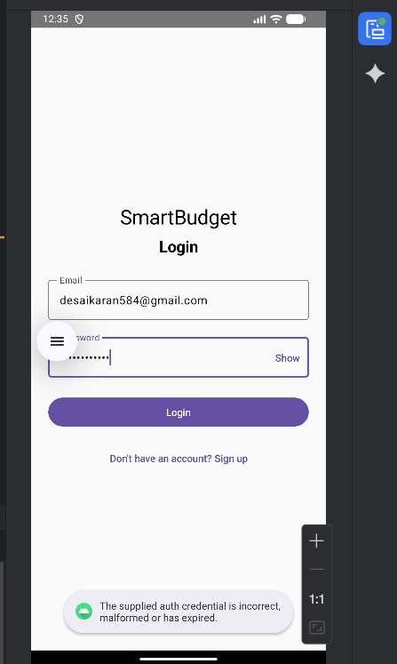

- Screenshot 2 – Dashboard Home Screen (After Successful Login)
This screenshot shows the Dashboard tab of the SmartBudget Home screen.
It includes:
- Top bar with SmartBudget title
- Placeholder total balance
- Recent transactions placeholder text
- Working bottom navigation bar (Dashboard, Groups, Profile)
This confirms that successful login redirects to the HomeScreen.

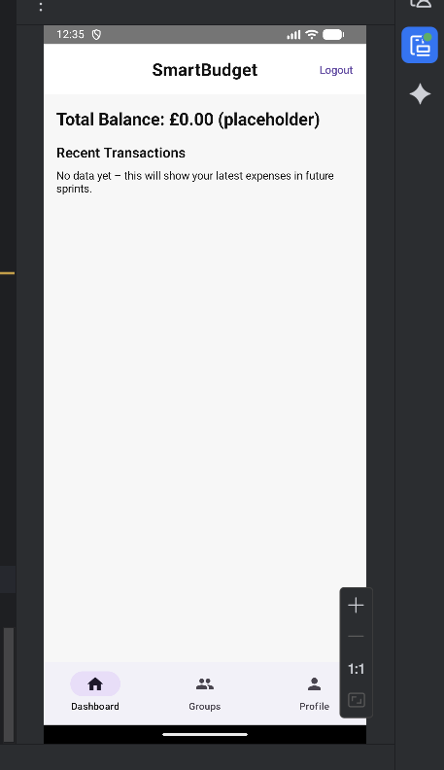

Screenshot 3 – Signup Screen (Create Account)
The signup screen allows new users to create an account using:
- Email
- Password
A “Show/Hide” toggle for password is implemented.
This demonstrates that Firebase signup UI is complete and fully functional for Sprint 3.

